4.44: a) If the gymnast climbs at a constant rate, there is no net force on the gymnast, so the tension must equal the weight; 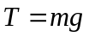.
b) No motion is no acceleration, so the tension is again the gymnast’s weight.
c) 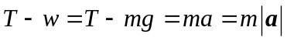 (the acceleration is upward, the same direction as the tension), so 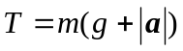.
d) 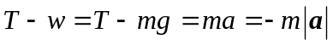 (the acceleration is downward, the same opposite as the tension), so 

